REVIEW OF 2021
CELEBRATING THE RE-OPENING OF OPERA
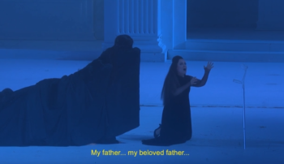
2021’s Salzburg Festival presented Mozart’s opera of love, jealousy and eternal damnation: Don Giovanni. If you haven’t yet seen Davide Lucianno’s magnificent performance as the self-destructive Don Giovanni, you’re in for a treat.

